**Quizzes: Docker for Application Packaging**

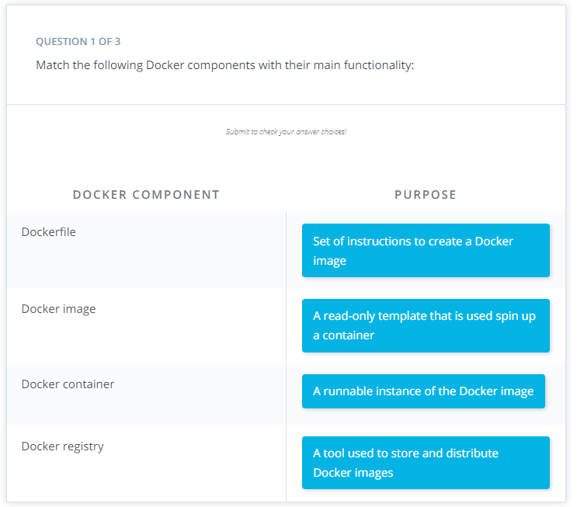

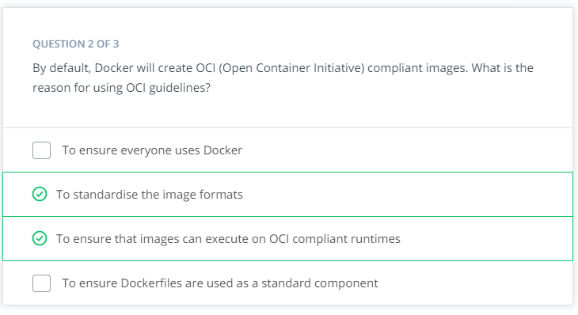

**QUESTION 3 OF 3**

What is the Docker command used to get the following output?

